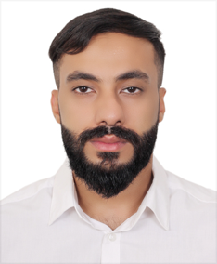

**Curriculum Vitae**

**Personal Data**

**Name** : Sayed Baqer hashem baqer alawi

**CBR No** : 9030207041

**Date Of Birth** : 14 February 1993

**Nationality** : Bahraini

**Phone No** : 37226614

**Address** : House 1820 - Road No 3637 – Block 736 - A’Ali

**Email : sayedbh@hotmail.com**

**Upscale Retail Sales**

**Overview**

For more than eight years working for Alshaya trading co. Recognized for delivering & unparalleled Customer service , a verifiable Track record for success Backed by impassable references . areas of expertise include :

♦ Exceptional Customer Service. ♦ Problems Solved.

♦ Merchandising & Display. ♦ Inventory & Pricing.

♦ Bilingual ( Arabic – English ). ♦ Work ethics , Team work.

**Employment**

**Sales associate** – A pluss store ( 3 years ).

**Cashier** – Lulu hyper market ( 10 months ).

**Sales associate & merchandising** – in Mothercare Alshaya at BCC ( 4 Years ).

**Educational Background**

**2011** - Graduate from al-tawoon Secondary School .

**2015 -** Improving self-Awareness – Horizons HRD .

**Personal:-**

Enjoy & Active in Internet surfing , Soccer & Photographing .